**ASSIGNMENT 04 – WordPress CMS Website**

**Instructions for completing template:**Replace **[bracketed red text]** with the requested information or screen capture.  
Replace **bracketed red text with black text**.  
Do not include full screen shot images, or full screen shots that are reduced in size. Use a snippet tool to capture parts of the screen and insert those images into the template.  
Do not remove tags (tag example [C01]) from this template. Please fill out all items and answer all questions. Please do not alter template formatting or delete parts of this template.

Part A - Student Information:   
 **1. Student Name: Abel Marin**

**2. Contact Info: (630) 608-8570**

**3. Email: marinabe1416@gmail.com**

**4. What day and date did you start this tutorial: Sunday, February 2nd**

Go back to the instructions and continue with Part B.Part B1- Shared Web Host WP CMS Website Information:   
Shared Web Host Name: [SiteGround] [B01]  
cPanel URL: [Enter cPanel URL here] [B02] \*Only for hosts with separate URL for cPanel  
Shared web host or cPanel Username: [amarin13@mail.depaul.edu] [B03]   
Shared web host or cPanel Password: [Dbeu!315] [B04]  
Domain Name: [abelm.sgedu.site] [B05]  
In Directory Name: [mod4assignment4] [B06]  
Website Admin Username: [abelmarinjr] [B07]  
Website Admin Password: [&53Y7ct5Hq] [B08]  
Database Name: [wp20] [B09]  
Table Prefix: [wpsp\_] [B10]  
WordPress CMS Website URL: [http://abelm.sgedu.site/mod4assignment4/] [Front End URL] [B11]

*Note: Please do not provide the Backend for B11 (above).*

-OR-  
Part B2- Pantheon WP CMS Website Information:  
**Assignment Website Site Name:** **[Site Name]   
Assignment Website Frontend URL:** **[WEBSITE FRONTEND URL]  
Website Admin Username:** **[ADMIN USERNAME]  
Website Admin Password:** **[ADMIN PASSWORD]**

-OR-  
Part B3- Cloud WP CMS Website Information:  
Note: instructor must be able to login to start the connection/container

1. **Cloud host/company Name: [Cloud Organization Name]**
2. **Cloud Account username (email): [Cloud account username]**
3. **Cloud account password: [Cloud account password]**
4. **Website Site Name:** **[Site Name]**
5. **Website Admin Username:** **[ADMIN USERNAME]**
6. **Website Admin Password:** **[ADMIN PASSWORD]**
7. **Assignment Website Frontend URL:** **[WEBSITE URL]**

Go back to the instructions and continue with Part C.

**Part C - WordPress CMS + Website Extensions + Comments**

1. Backend Screen capture of the dashboard > Themes   
   **[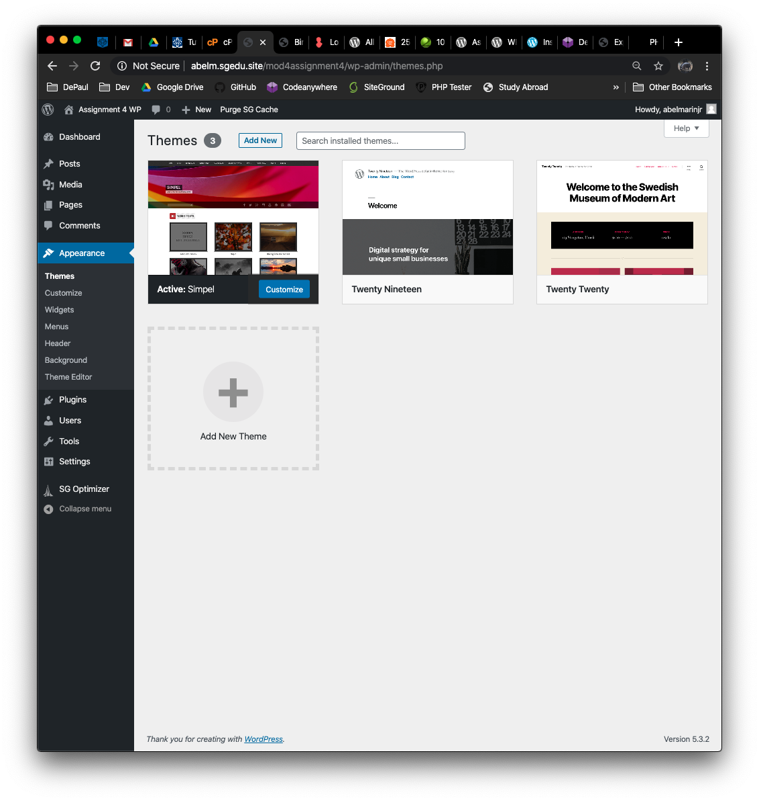]** [C01]
2. Backend Screen capture of the dashboard > Plugins   
   **[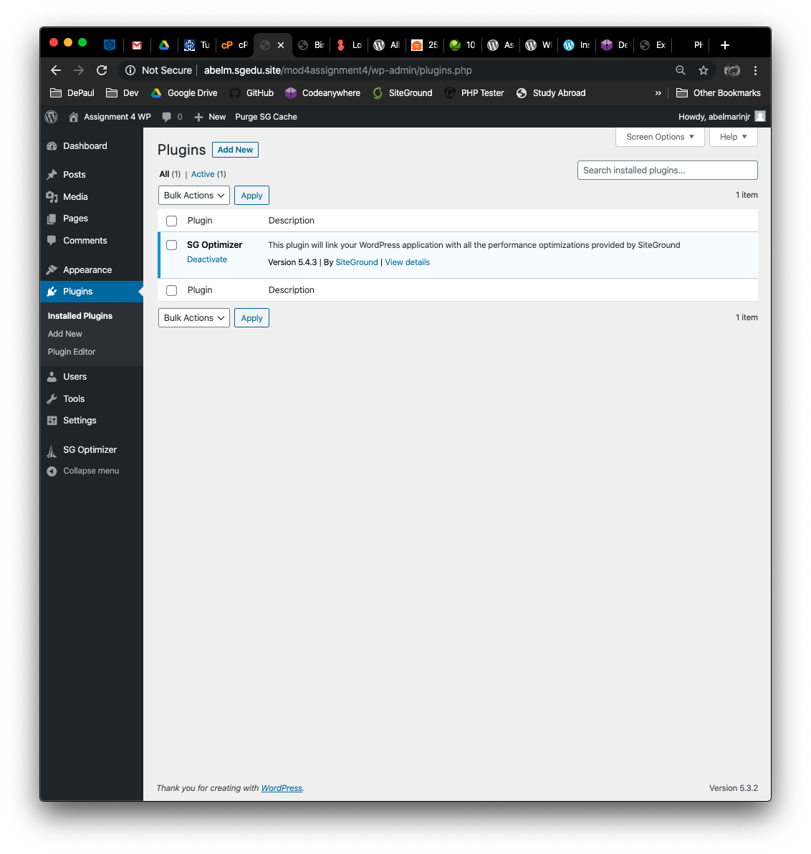]** [C02]
3. Backend Screen capture of the dashboard > Media library page with List view selected  
   **[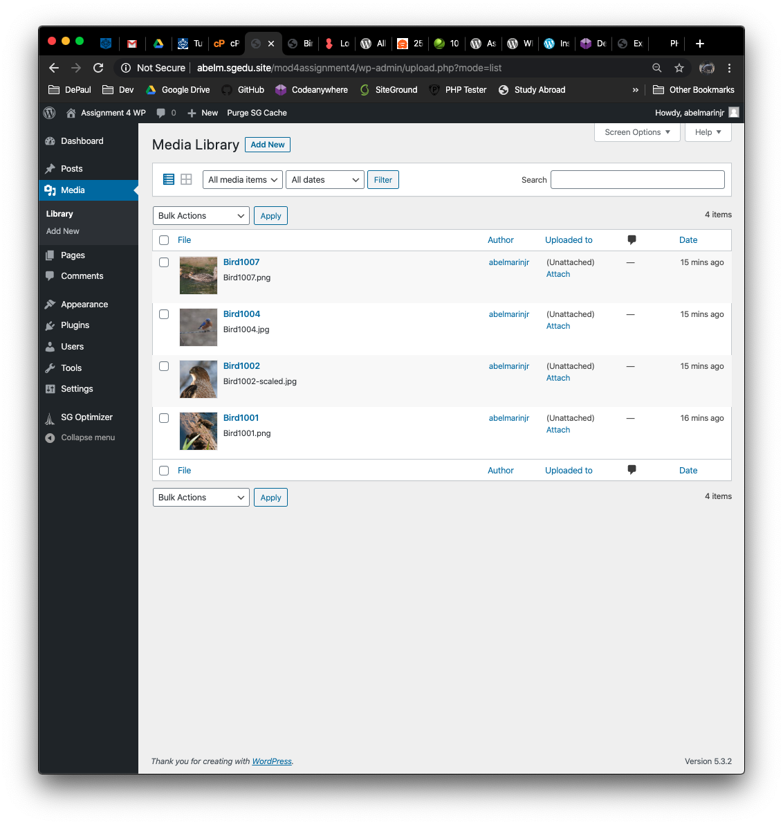]** [C03]
4. Backend Screen capture of the dashboard > Menu page   
   **[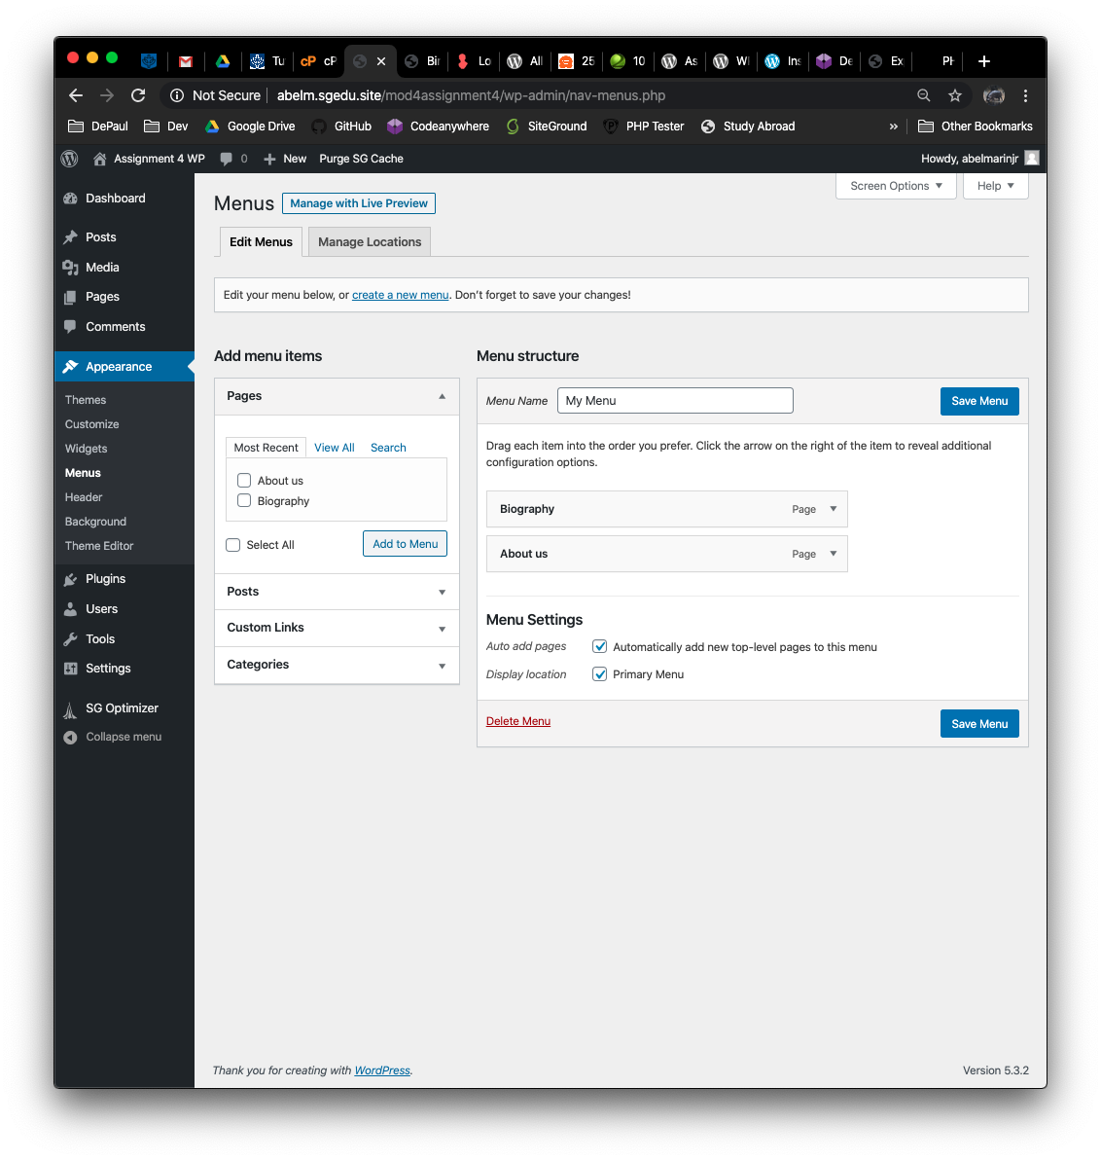]** [C04]
5. Backend Screen capture of the dashboard > Posts >Categories  
   **[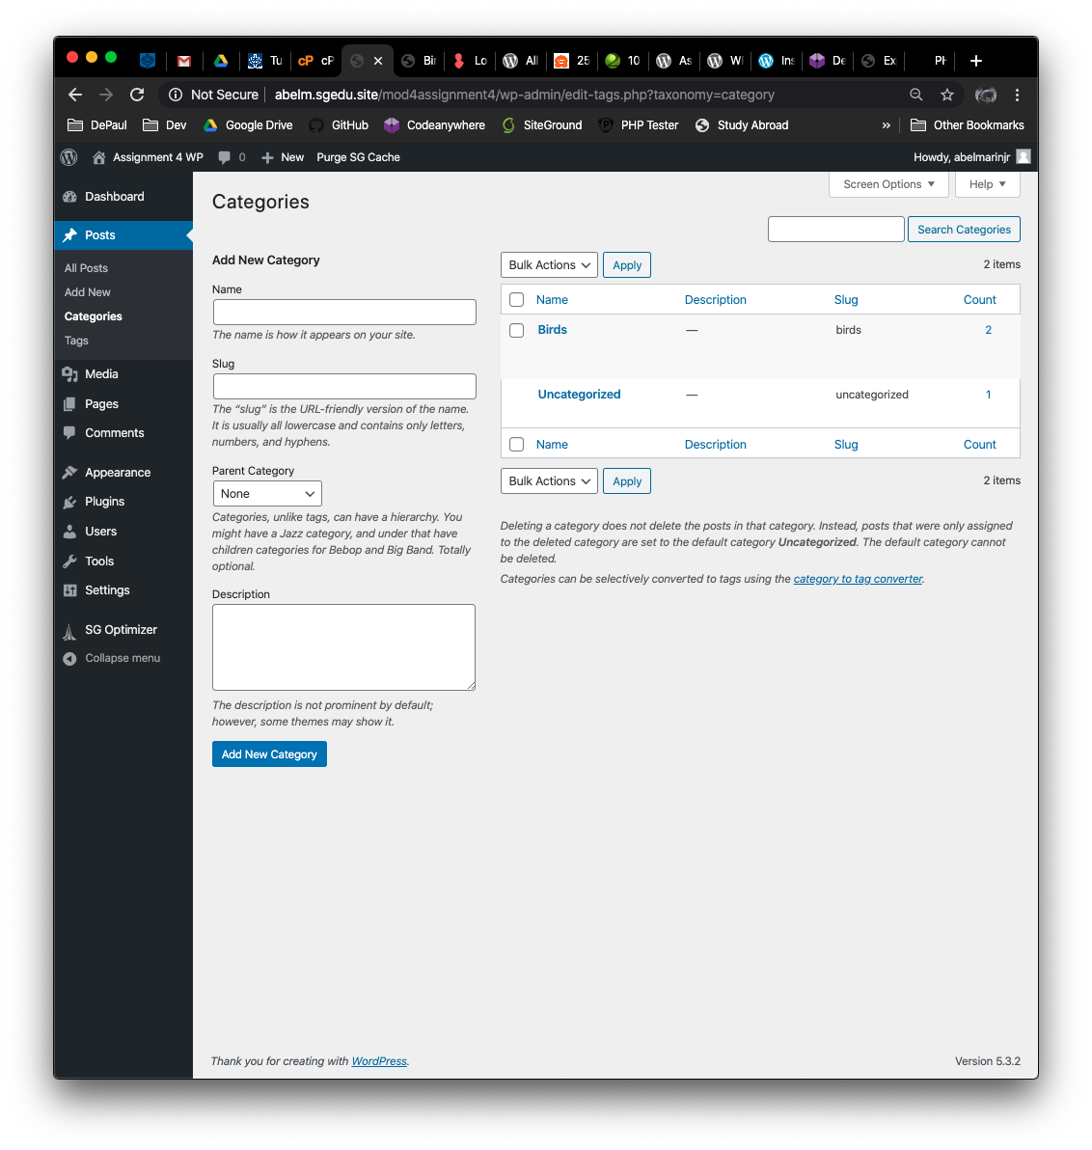]** [C05]
6. Backend Screen capture of the dashboard > Post > Tags   
   **[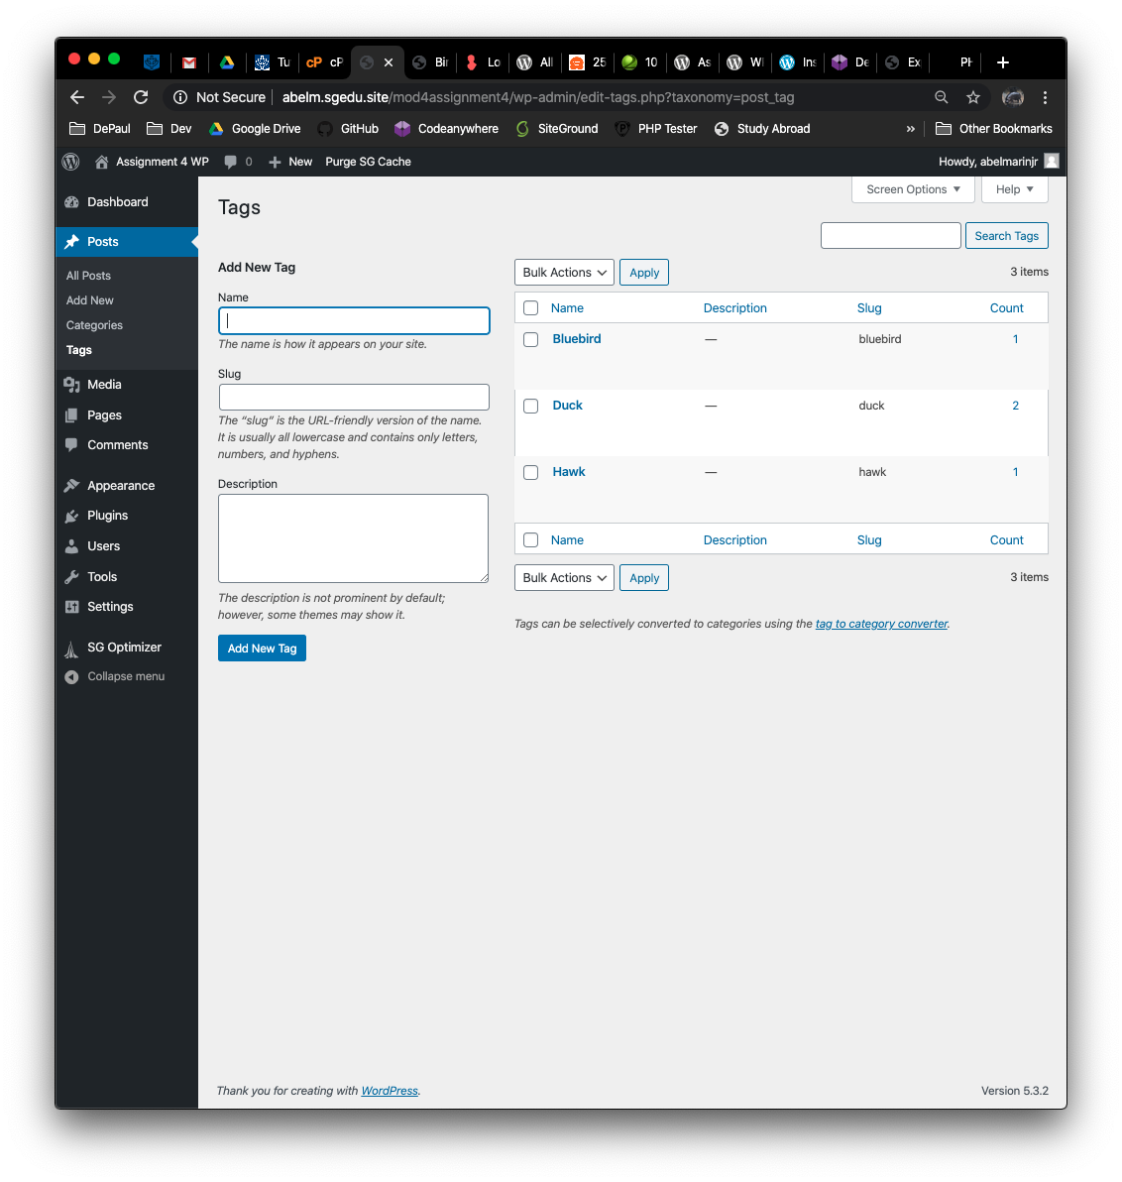]** [C06]
7. Backend Screen capture of the dashboard > Posts (showing comments in the list)  
   **[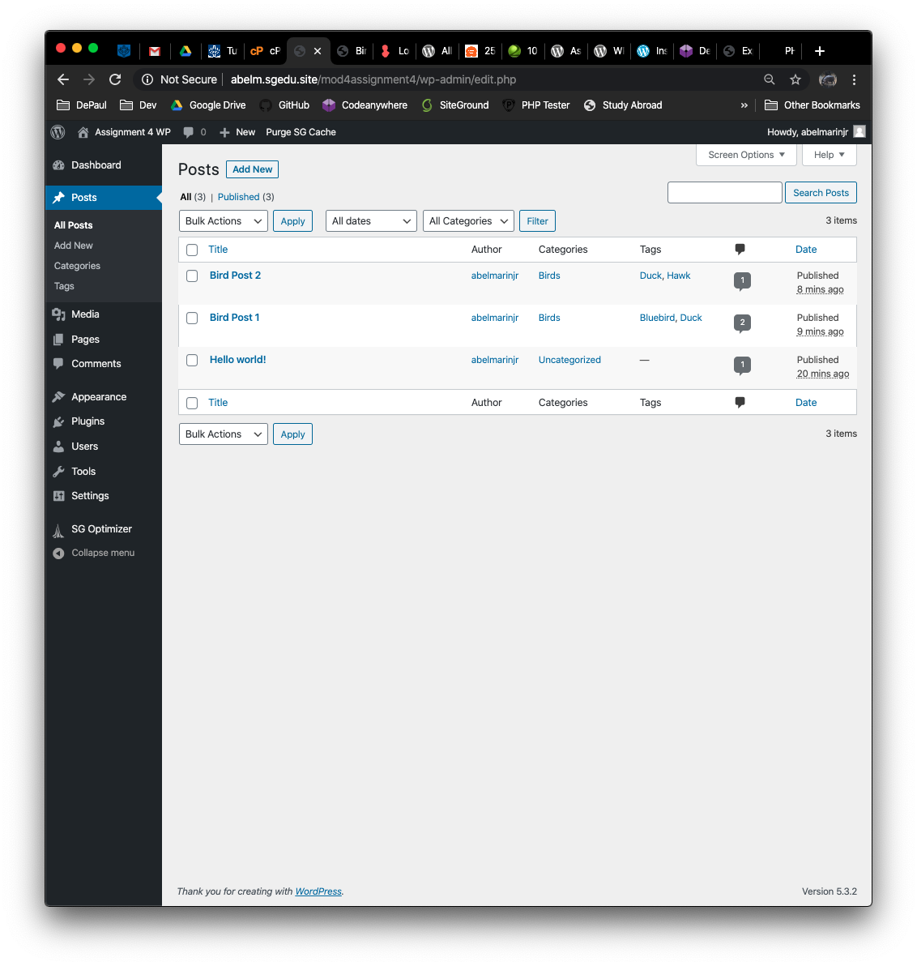]** [C07]
8. Backend Screen capture of the dashboard > Pages (showing comments in the list)  
   **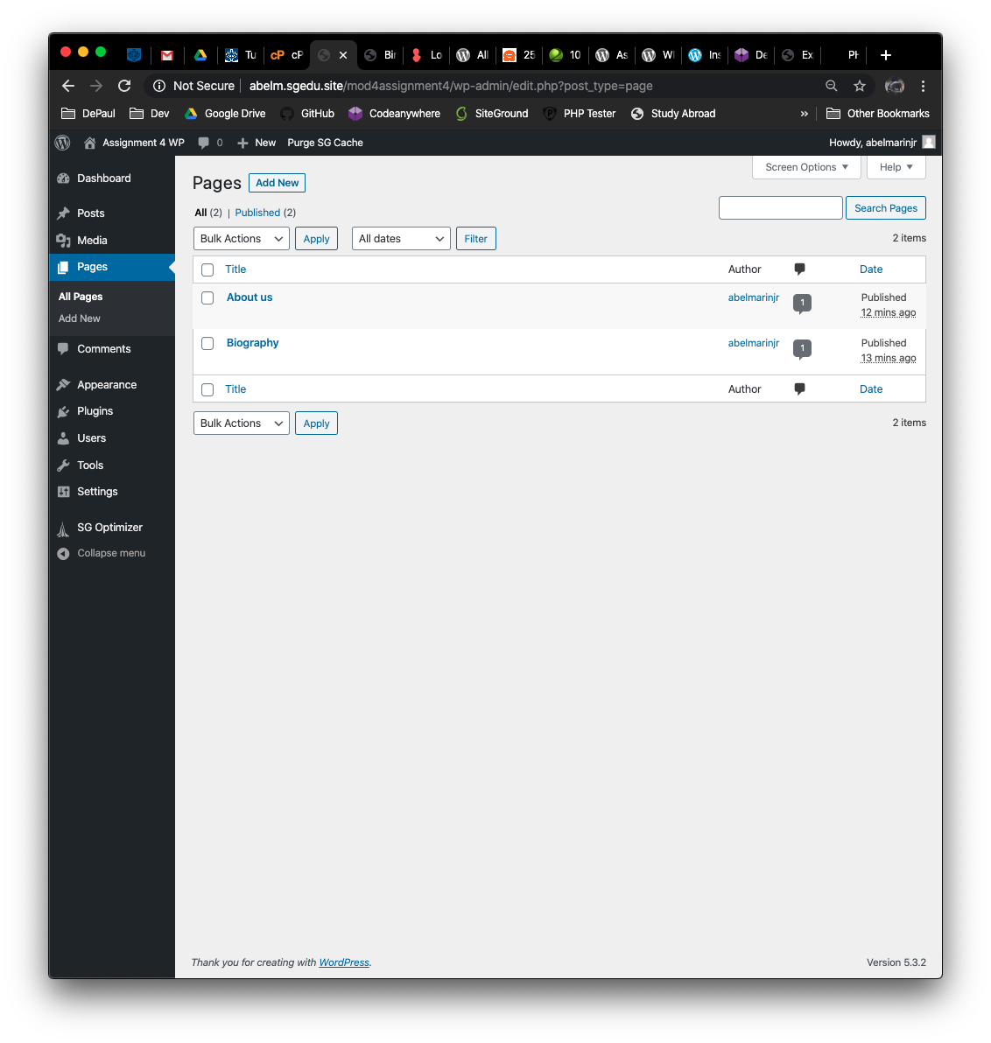[]** [C08]
9. Screen capture website front-end showing menu with the About page selected and displayed  
   **[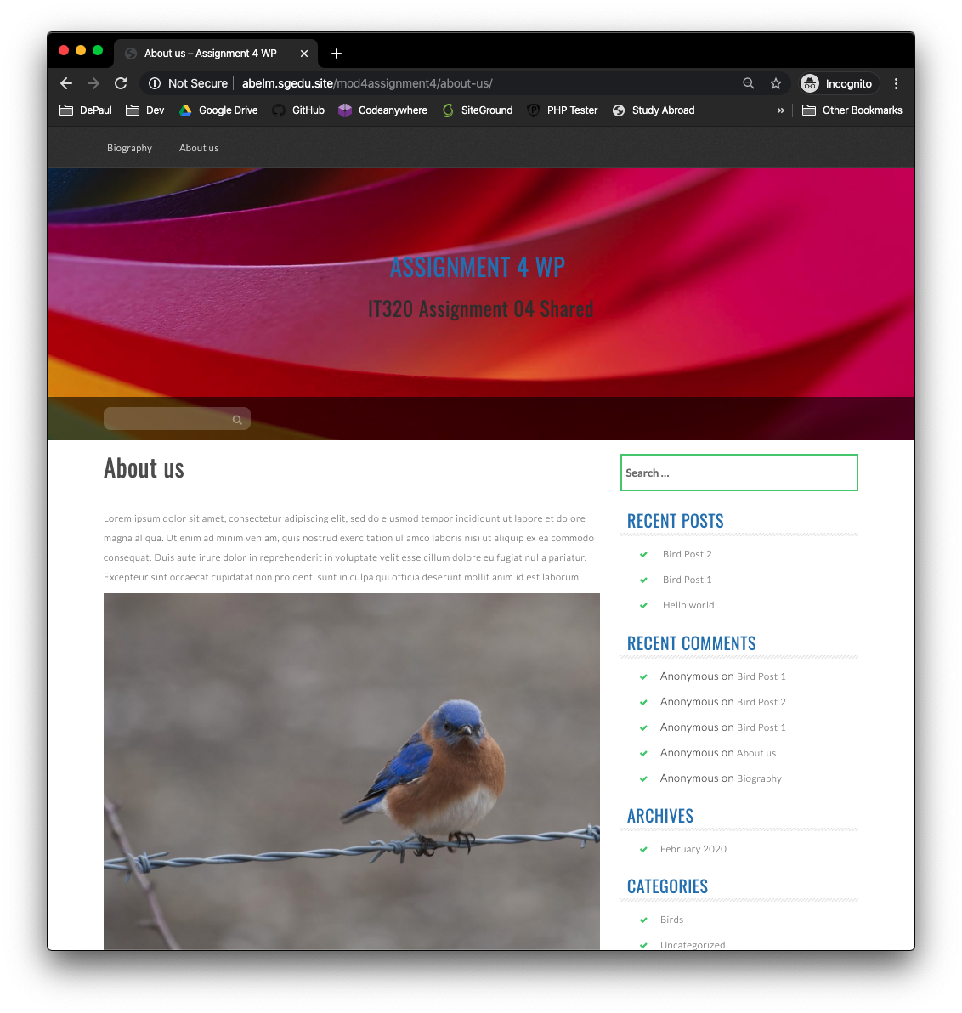]** [C09]
10. Screen capture website front-end showing Home page with the first Post visible   
    **[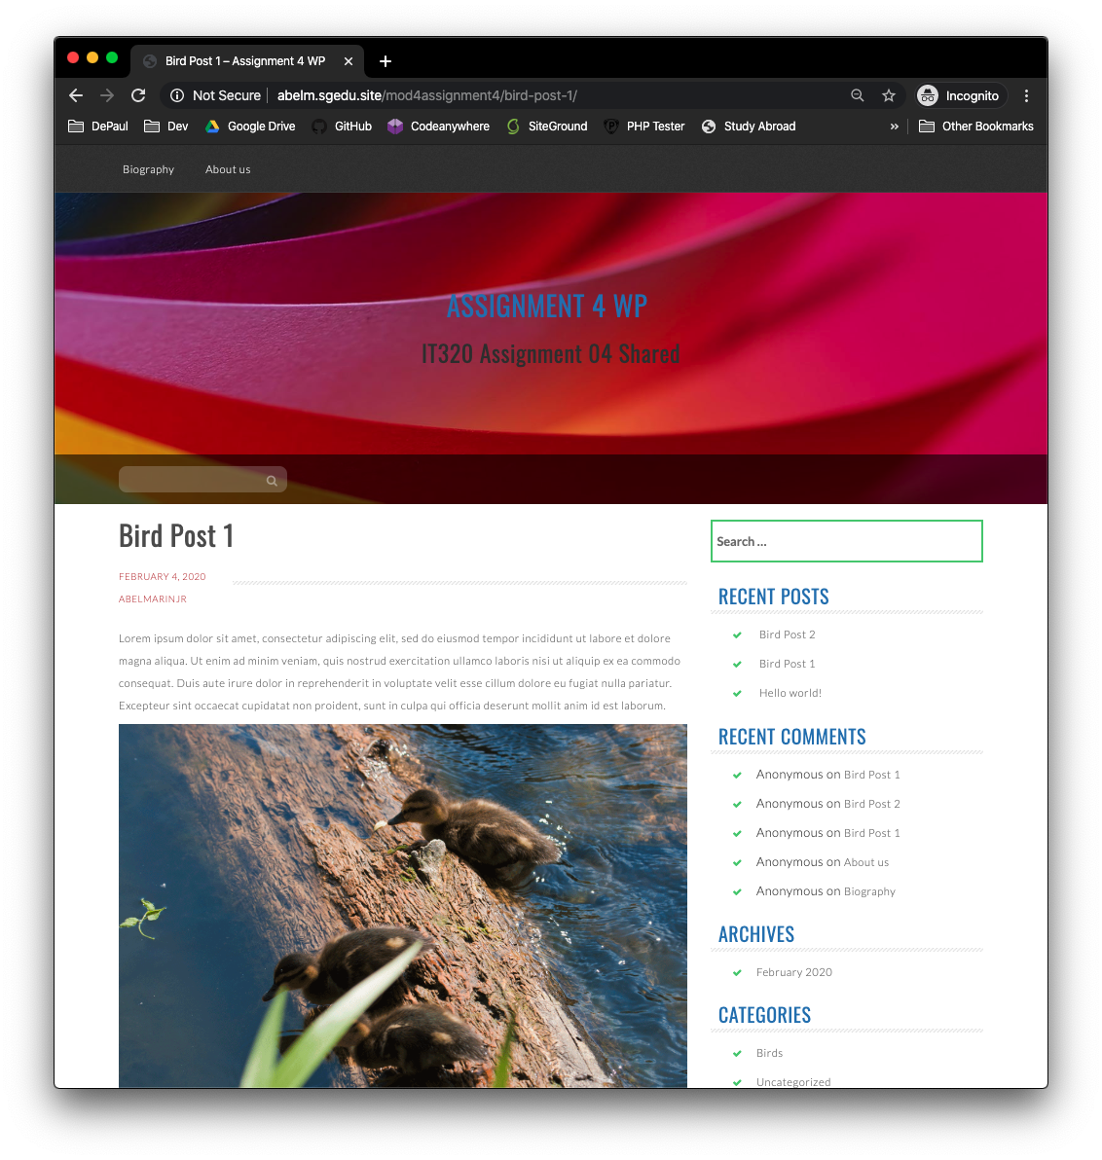]** [10]

**Part D – Contact Form Best Practices**

1. List of all the Form Plugin names reviewed:

**[Contact Form 7, Flamingo, Honeypot for Contact Form 7, Contact Form CFDB7, Ninja Forms]** [D01]

1. List of Form plugin names tested:

**[Contact Form 7, Flamingo, Honeypot for Contact Form 7, Contact Form CFDB7]** [D02]

1. OPTIONAL screen capture of your From plugin feature comparison chart:  
   **[SCREEN CAPTURE HERE]** [D03]
2. Form Plugin names selected:

**[Contact Form 7, Honeypot for Contact Form 7, Contact Form CFDB7]** [D04]

1. Backend screen capture of your site plugins list page, form Plugins you selected and installed  
   **[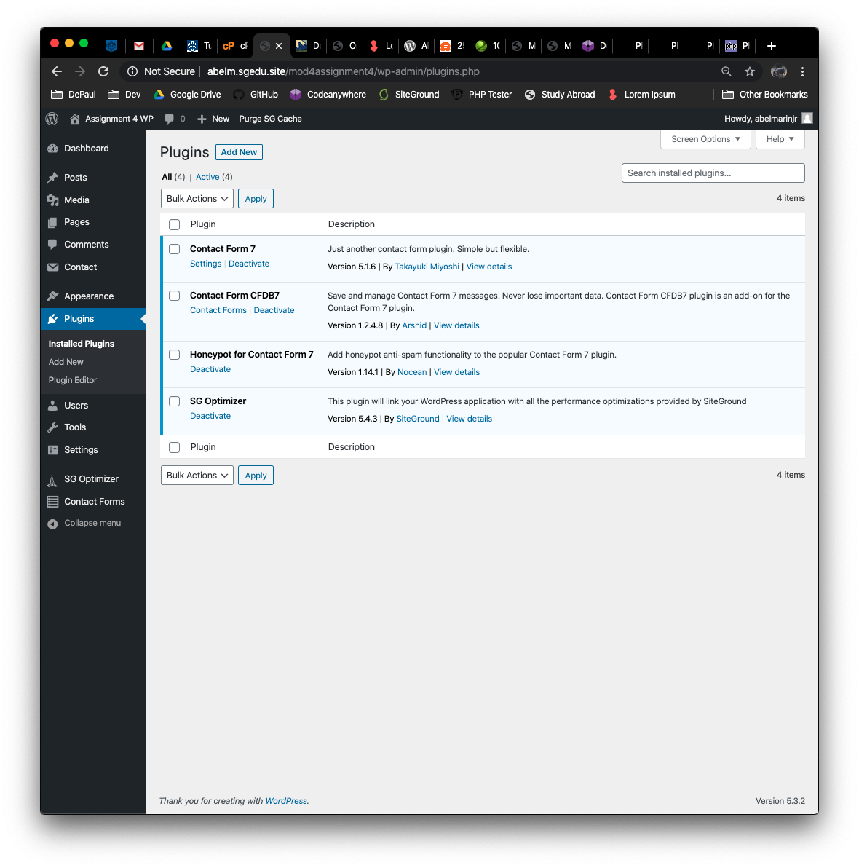]** [D05]
2. Screen captures of the 2 new backend forms – showing the form fields and settings

**[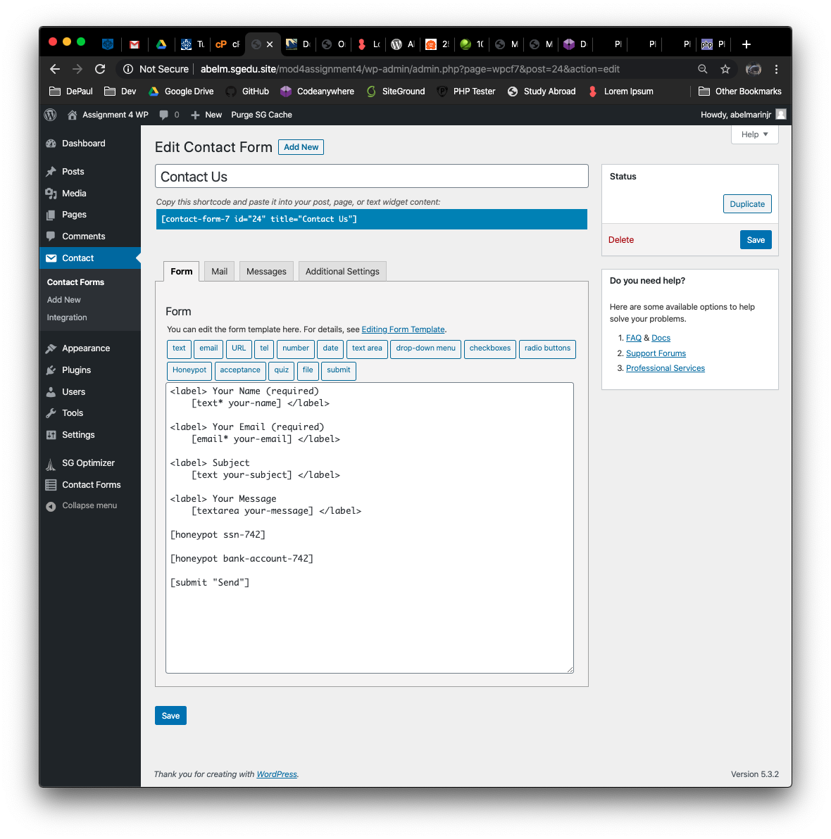]** [D06-1]  
**[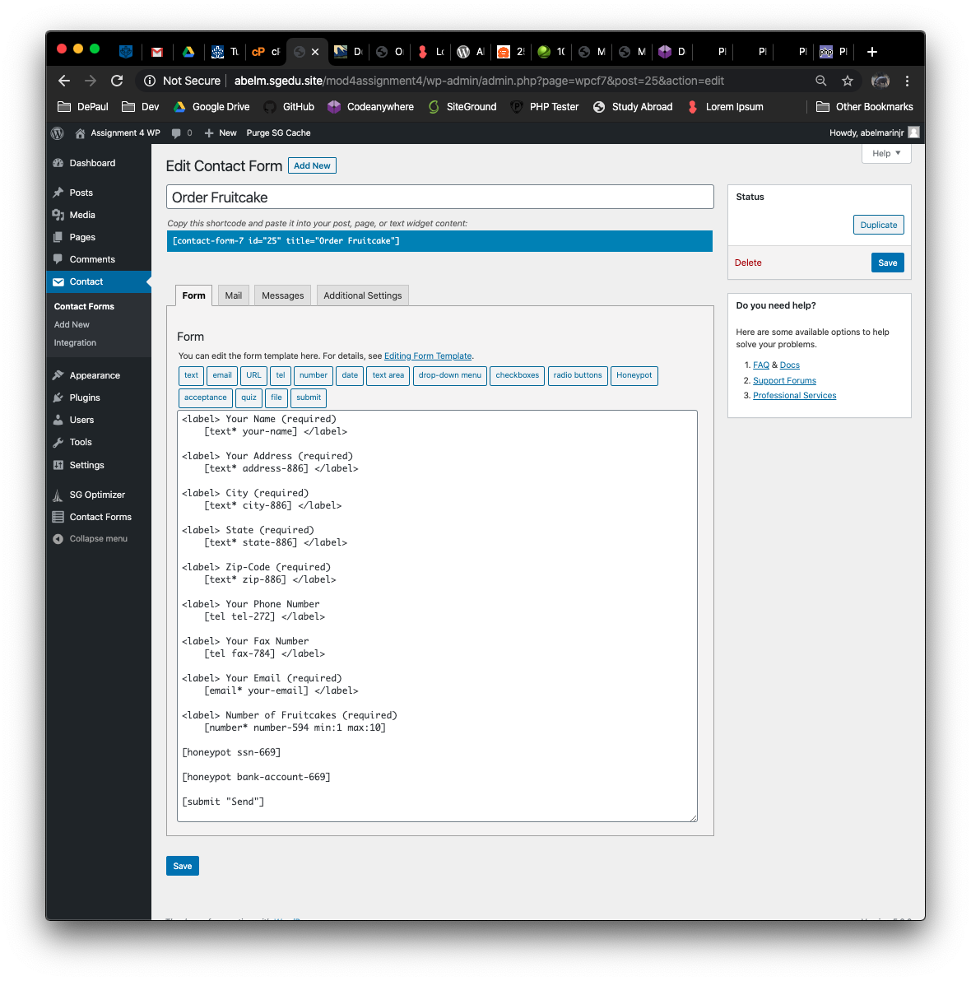]** [D06-2]

1. Backend Pages where you added the SHORTCODES of the forms to the Page

**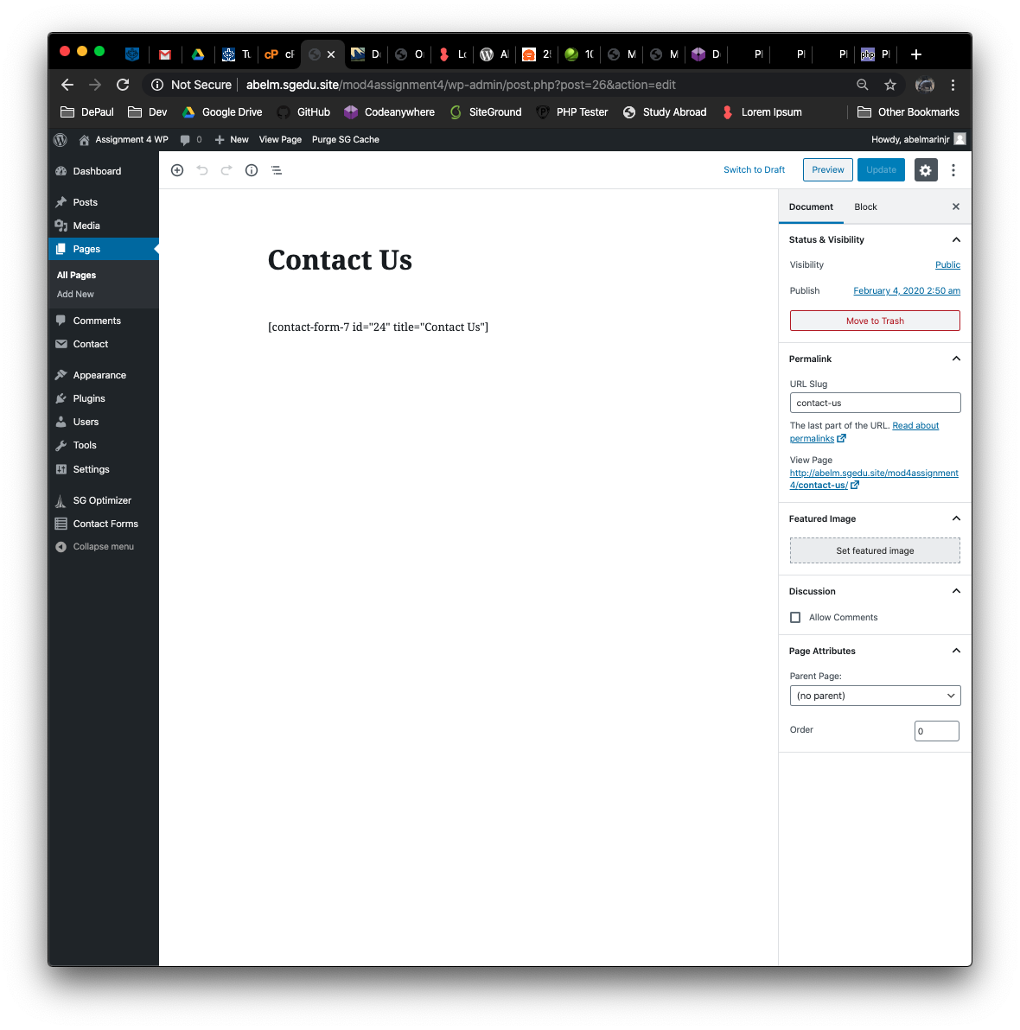[]** [D07-1]  
**[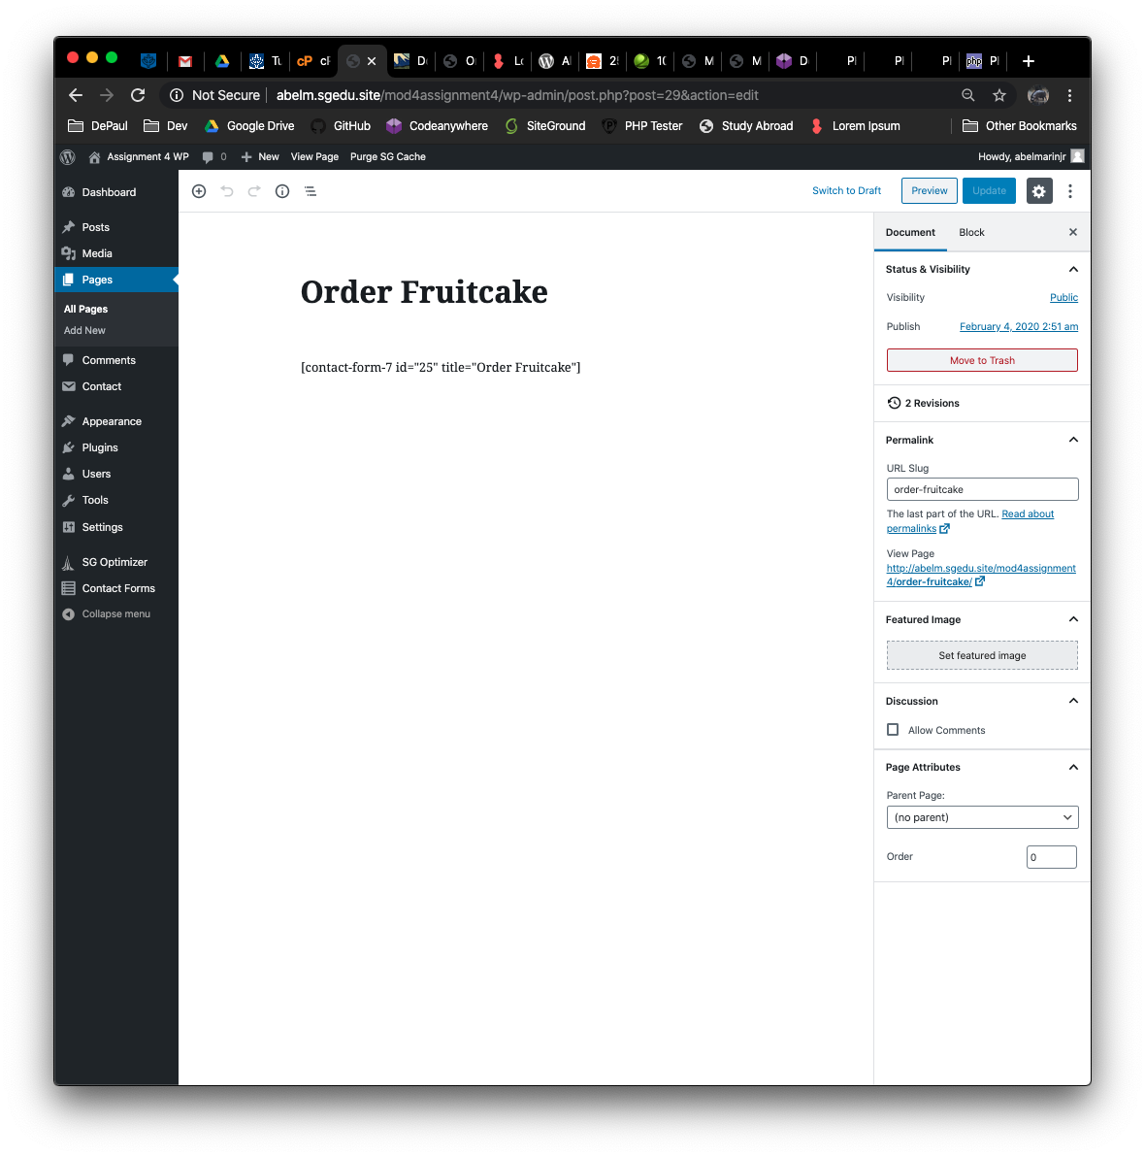]** [D07-2]

1. Front end client facing screen captures of the website pages, showing the forms selected

**[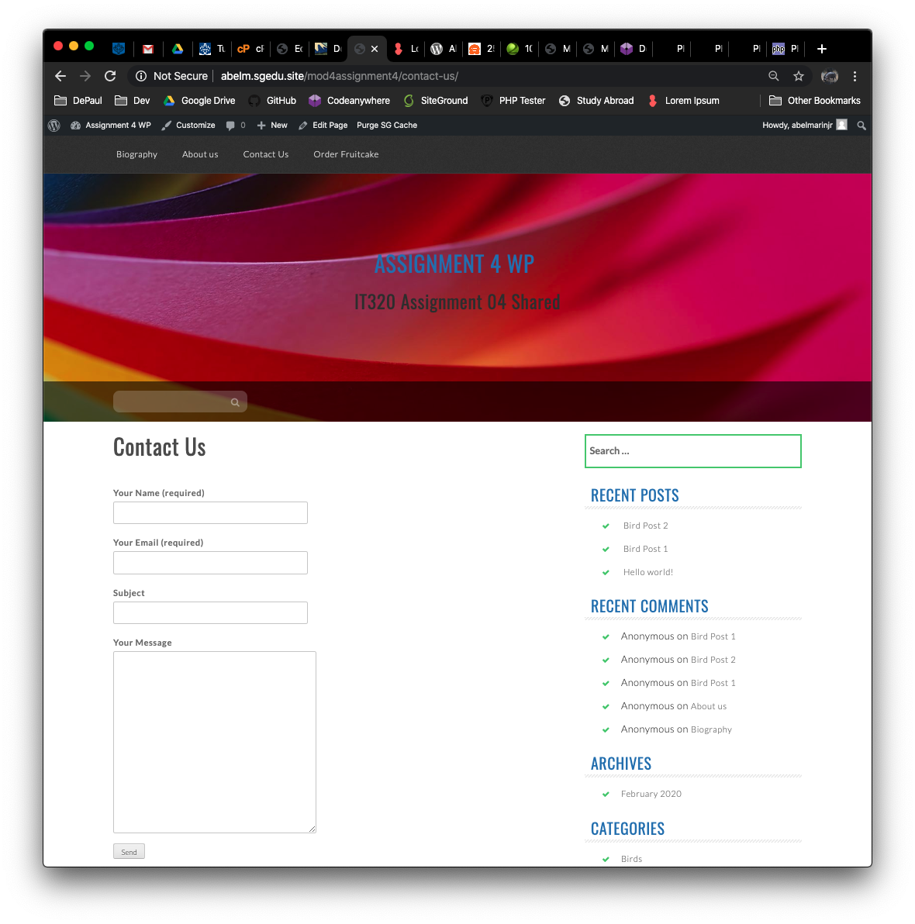]** [D08.1]  
**[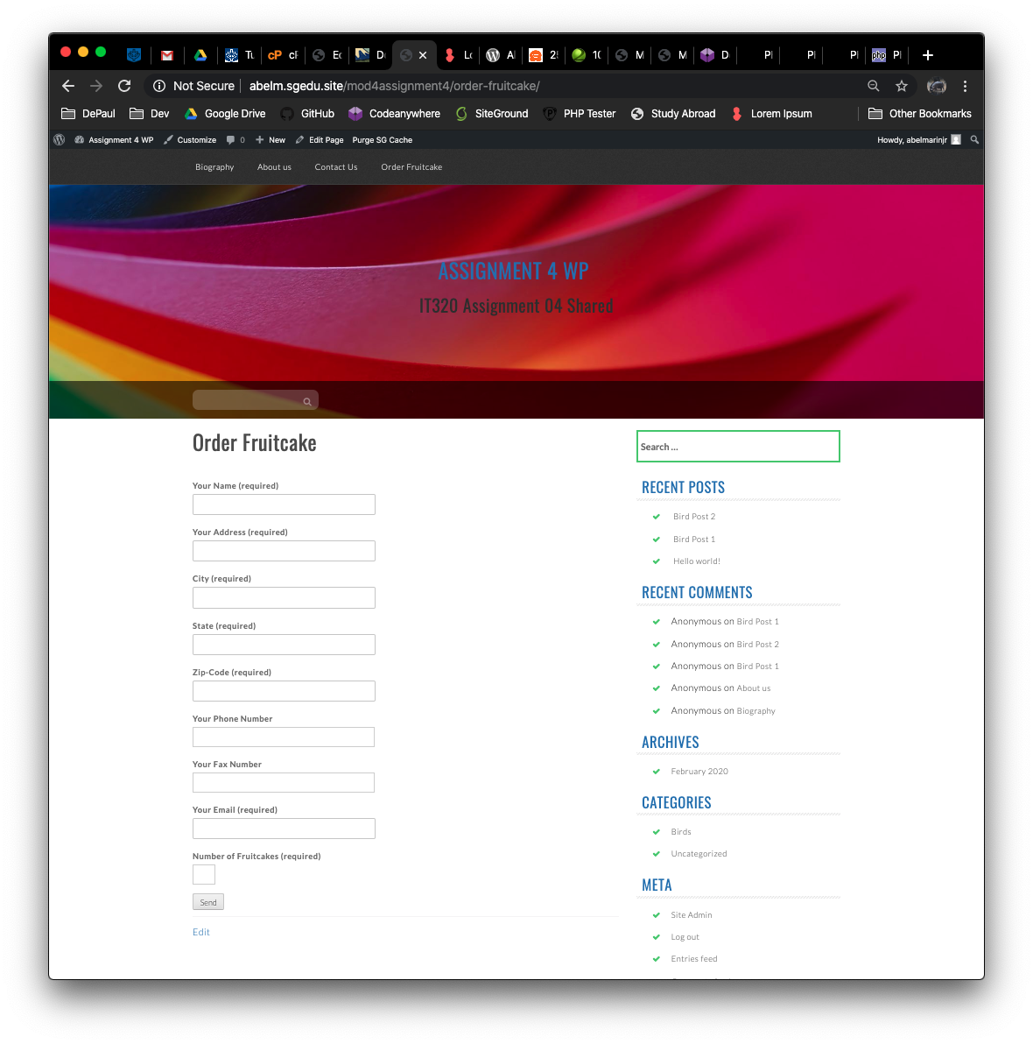]** [D08.2]

Go back to the instructions and continue with Part E.

PART E - Exercise Best Practices to Add WordPress Widgets

1. Describe how you used plugin best practices to find and select the plugin widget here.

Note: Best practices are what steps you took very validate that the plugin can be used safely on your website, before you installed or activated it.  
**[Before starting I figured I may as well choose widgets based on how they show off my social networks. To do this I searched up several different widgets which could’ve helped show off my Instagram, github, youtube, and other social networks. Once I had found a few options I made sure to see if it is 1) compatible with your wordpress version 2) whether or not it is actively maintained 3) whether or not it is used by a large number of websites 4) and the number and quality of reviews. I chose the ones which matched most of these criteria. ] [E01]**

1. What are the exact names of the 4 widgets you used?   
   Please answer here  
   Widget 1: [ **Social Gallery and Widget** ] **[E02.1]**  
   Widget 2: [ **WP Google Maps** ] **[E02.2]**

Widget 3: [ **Social Count Plus** ] [**E02.3]**Widget 4: [ **YouTube widget responsive**  ] [**E02.4]**

1. Take screen captures of the WordPress front-end client facing WordPress site showing the 4 new widgets and paste them here. **Paste as many screen captures as it takes, to show all 4 widgets.   
   [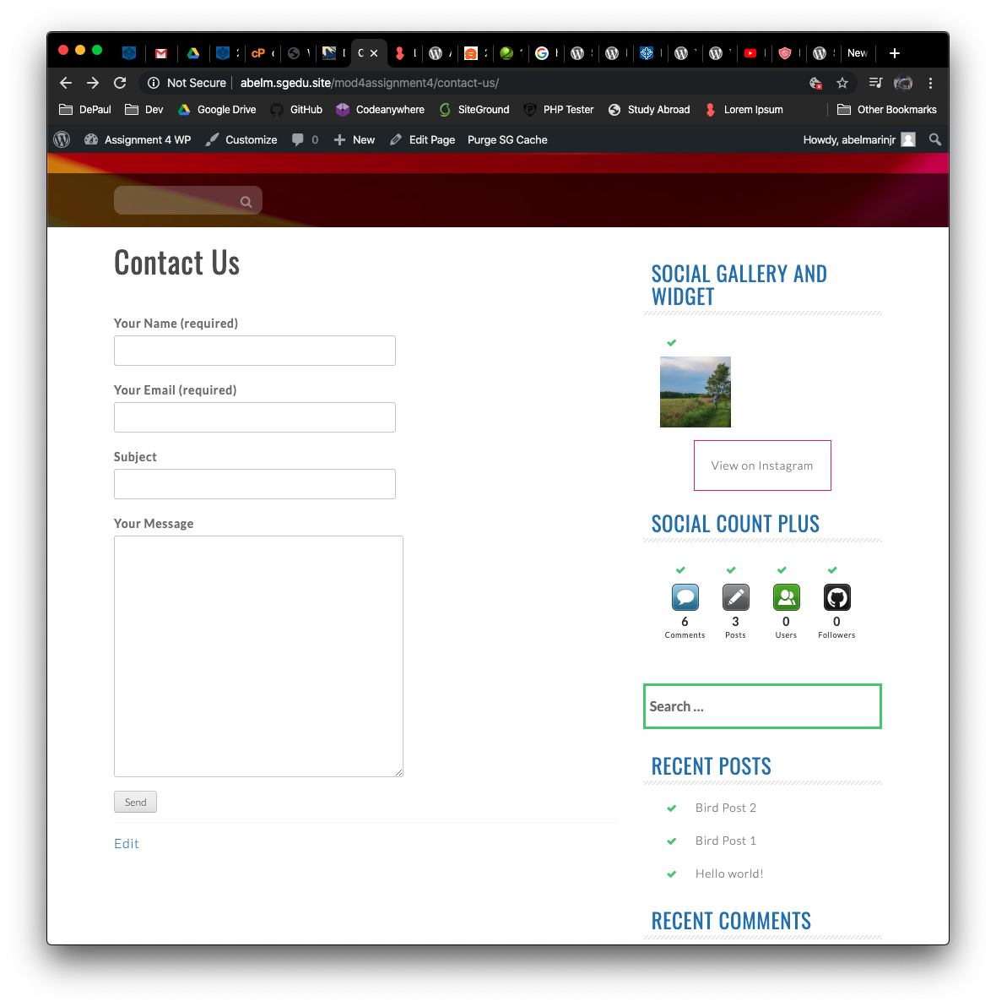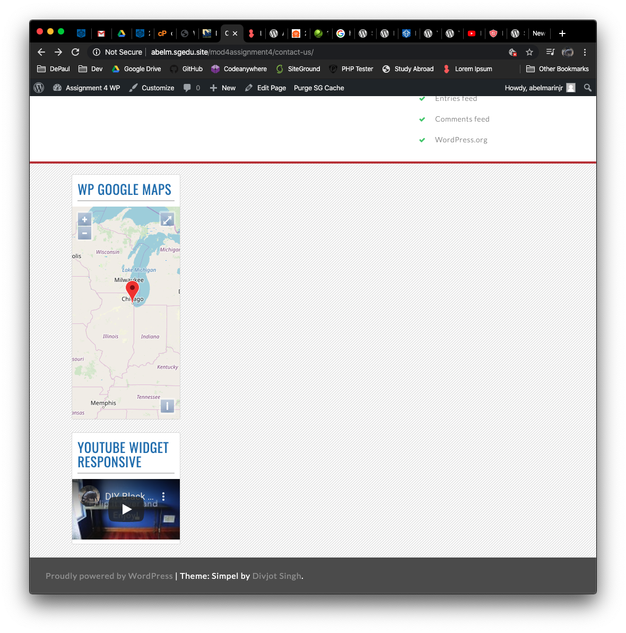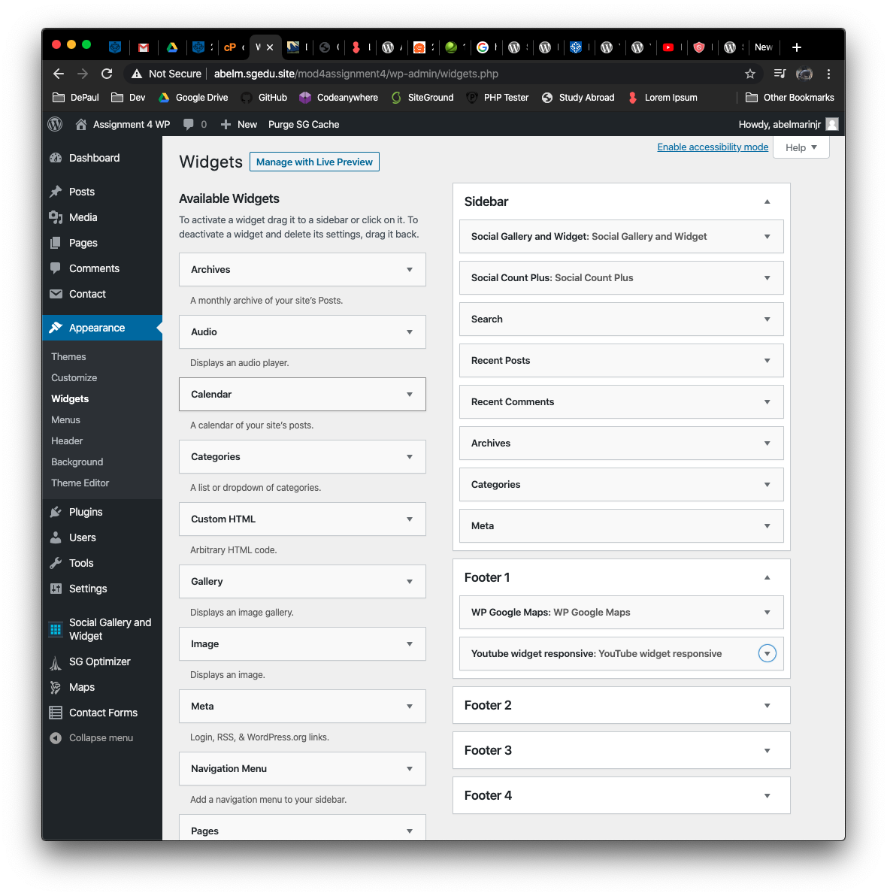] [E04]**

Go back to the instructions and continue with Part F.

PART F: PHP Questions and Answers

1. Look at the PHP code below. Write a PHP “foreach” statement that iterates through the $fruits array. Please note do not use VARDUMP, or a for statement. Write your code and test it on a Web emulator and take a screen capture of the working code and paste it below.

|  |
| --- |
| $computers = array( ‘Apple’, ‘IBM’, ‘Zerox’, ‘Stratus’, ‘Aspire ‘ ) ; |
| **[F01]** |
| **** |

1. Look at the PHP code below. Which arguments are default function arguments?   
   And how do you know which arguments are default?

|  |
| --- |
| HD:private:var:folders:vh:lbh1qypx7zldldk1l9f6tpsc0000gn:T:2019-12-20_11-45-08.png |
| **[F02]** |
| **[$argB and $argC ]** |
| **[ These two arguments are default because they both display an equal sign followed by a default values for when no value is supplied. These values are 5 and 10 respectively. ]** |

1. Look at the PHP code below. What which arguments are optional and how do you   
   know?   
   Hint: Be careful. If you are not 100% positive, look it up in the presentation.

|  |
| --- |
| HD:private:var:folders:vh:lbh1qypx7zldldk1l9f6tpsc0000gn:T:2019-12-20_11-48-30.png |
| **[F03]** |
| **[ $argC ]** |
| **[ $argC is an optional argument because the value of $argC is set to be an empty string. This means that it is permissible to pass no value for this argument. ]** |

1. Look at the PHP code below. Write PHP code that uses the prewritten function gettype and display the type of each variable using an echo statement. Test your code on a web emulator. Take a screen capture of the working PHP code and paste it below.  
   Please separate each output line with an HTML <br> tag.  
   Info on gettype:

<https://www.php.net/manual/en/function.gettype.php>

|  |
| --- |
| HD:private:var:folders:vh:lbh1qypx7zldldk1l9f6tpsc0000gn:T:2017-06-26_16-59-09.png |
| **[F04]** |
| **[Screen Capture Here]**  **** |

**For Help with 6 0n, please refer to presentation “M04 -08- Introducing PHP Classes and Objects”**

1. Write PHP code for a simple class named person with one public data member variable named

$first\_name. Also code a get and set accessor functions for the $first\_name variable.   
Write PHP code to instantiate the class and write a PHP statement to set the first name to a value and another statement to output the first\_name variable value using the get\_accessor.   
Code and test on PHPTester.   
Test your code on a web emulator. Take a screen capture of the working PHP code and paste it below.

|  |
| --- |
| **[F05] [Screen Capture]**  **** |

1. Examine the function below and answer the question, are the function arguments pass by value or pass by reference?

|  |
| --- |
| HD:private:var:folders:vh:lbh1qypx7zldldk1l9f6tpsc0000gn:T:2019-12-20_12-00-27.png |
| **[F06] [ They are pass by reference. I can tell since both arguments start with an ampersand or &. ]** |

Go back to the instructions and continue with Part H.

**Part G– Assignment Wrap up:**

1. **Did you have any problem or issues completing this assignment?  
   This is not an optional question.   
   [No] [G01]  
     
   If you answered yes to this question, please elaborate and be specific.  
   If you had trouble with a specific question, please identify it by number and explain what you did not understand or had problems with.  
   I can only improve this assignment with your help.**
2. **[List problems here] [G02] \*Only if you answered Yes to #1 above**

Submit this completed template to the correct D2L assignment dropbox.If you prefer not to navigate by hand to the D2L dropbox, take advantage of the dropbox link in the D2L this module’s section. This link will take you to the correct assignment dropbox location.